Sreeti Ravi

Visualize Geospatial Data

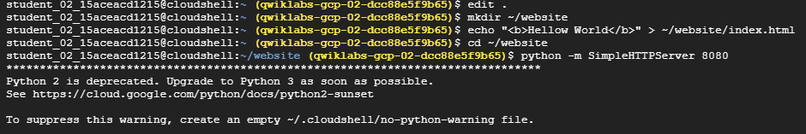

Initial page (with map)

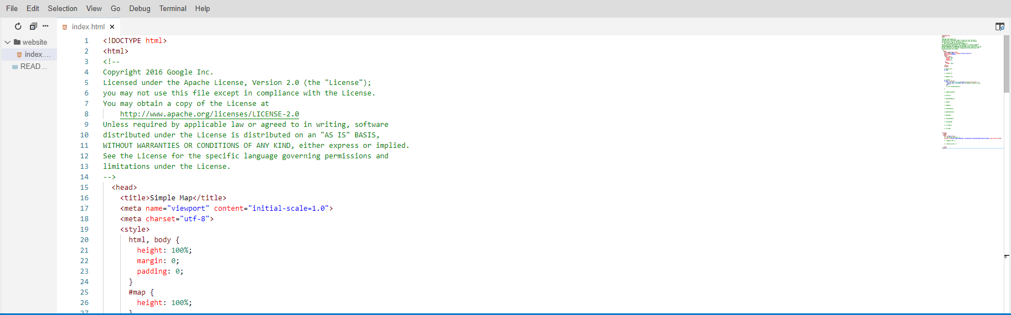

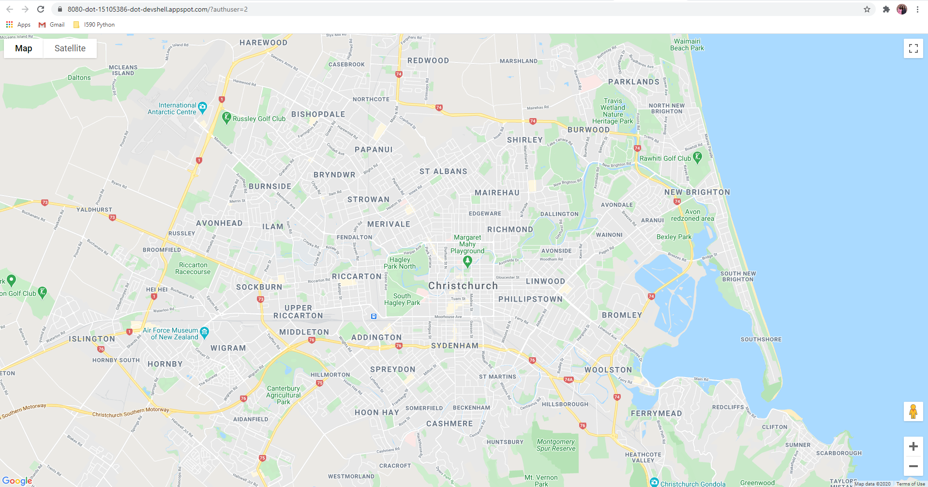

Set the map to New York City

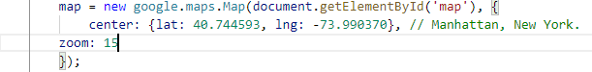

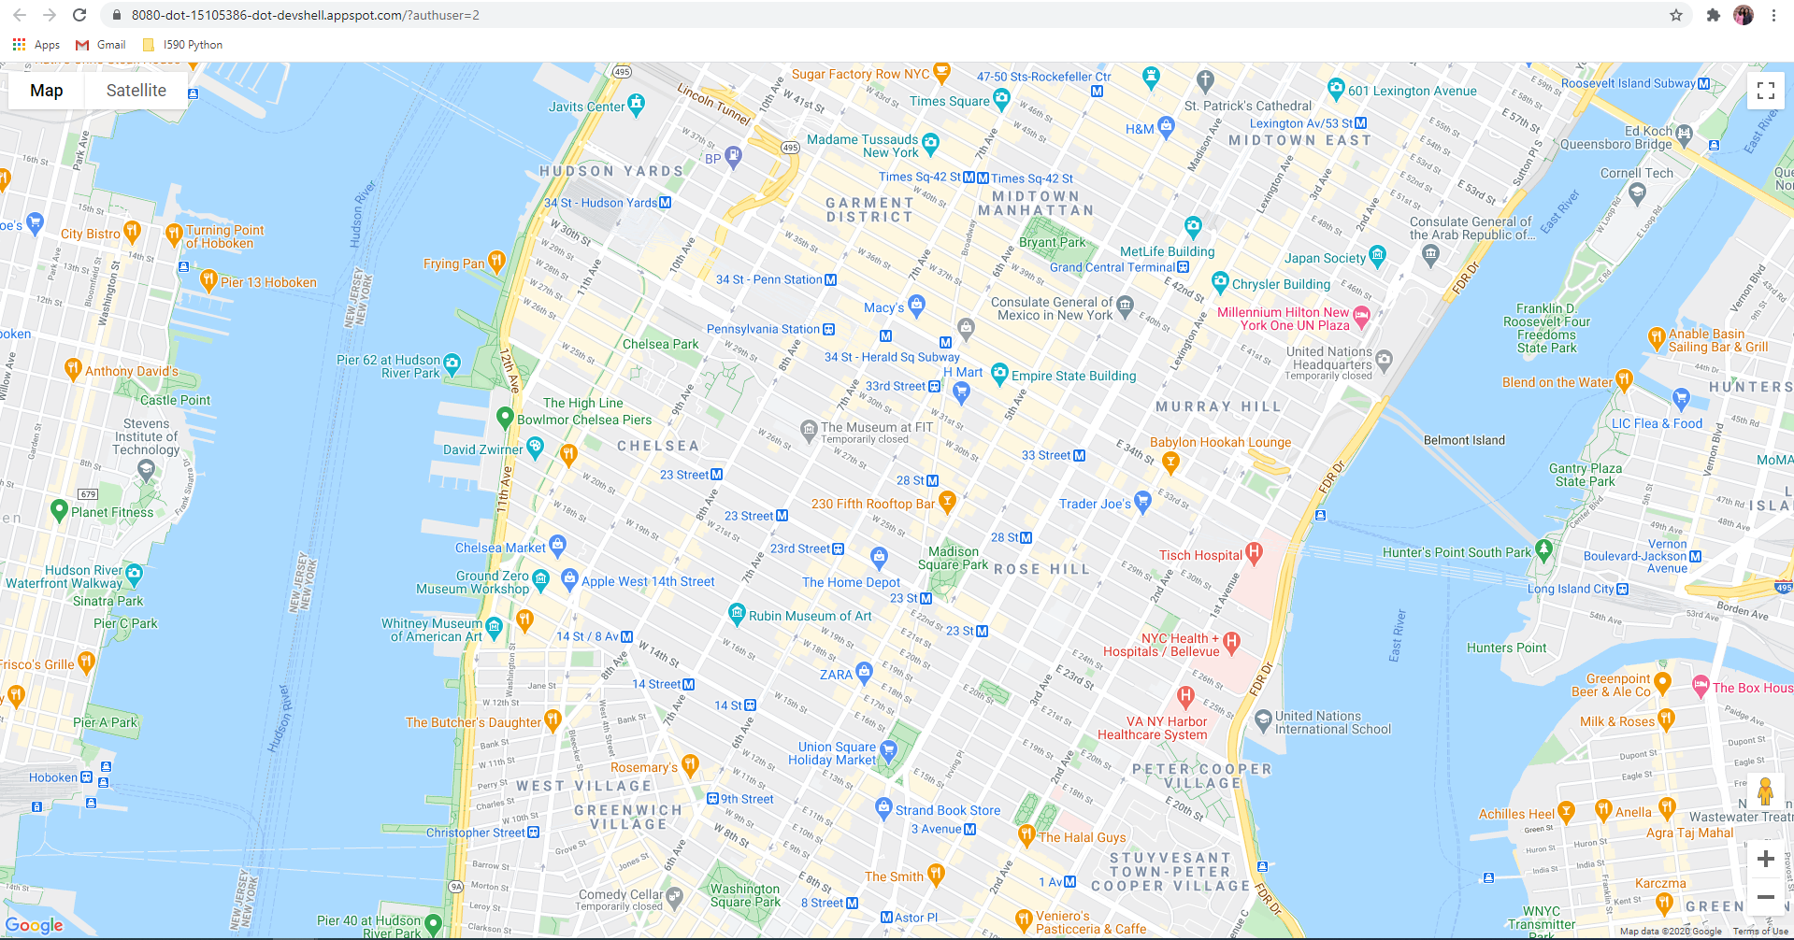

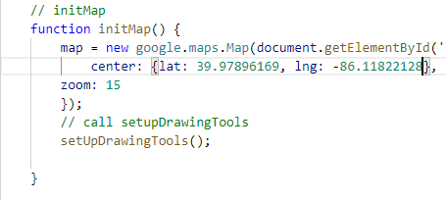

0

Enable the features to draw and visualize the data

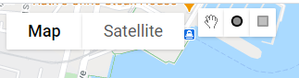

Using BigQuery Client Api

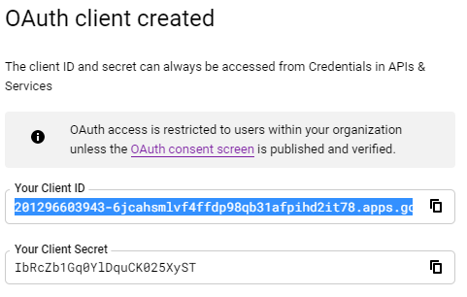

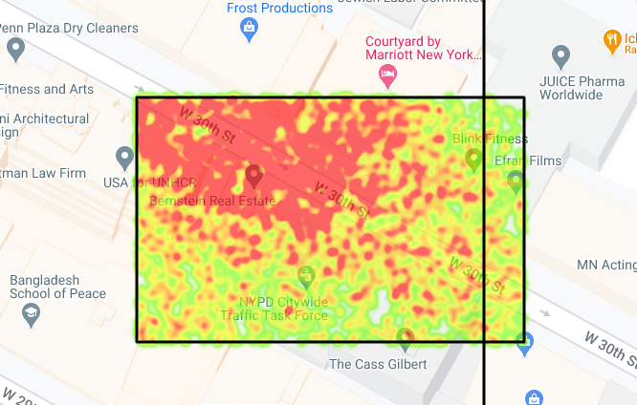

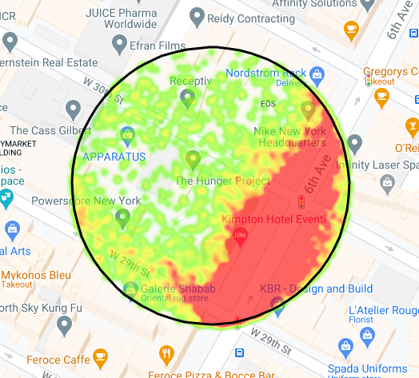

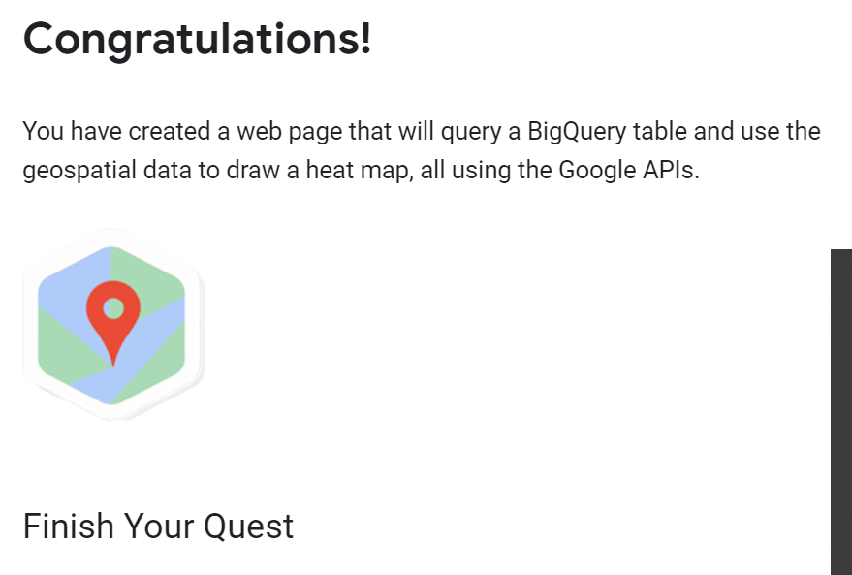

My experience with APIs in the past was work and it involved writing APIs using C#, but this was my first time using Google APIs. I thought the API interface was user-friendly and had many options for things to do. The API functions seem relatively like what I am used to. The BigQuery Client API was helpful in not having to write chunks of code. This was also my first time querying geospatial datasets but follows the same logic as querying anything else. I think geospatial data is a little more technical than other kinds of data. Geospatial data uses latitude and longitude to query. Visualizations are useful for geospatial data because it lets us see patterns and trends.

The 7 stages of understanding data are acquire, parse, filter, mine, represent, refine and interact. In this activity, we got the Google Map from the Maps Javascript API. We didn’t have any data to parse. The filtering happened when a shape was drawn on the map. For represent, the visual model we chose is a map. For refine and interact, the map let users zoom in and out and also draw circles or rectangles to see a heat map within that area.